A **Single Action Controller** in Laravel is specifically designed to have only one callable method, the __invoke() method. By definition, it cannot include additional methods for routing purposes because Laravel treats the __invoke() method as the single entry point for the controller.

**Single Action Controller** এর মধ্যে একটি মাত্র মেথড থাকতে পারে।

১.Controller বানাব।

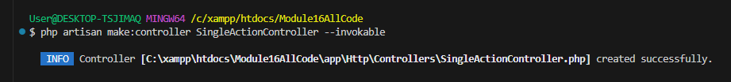

২.Controller এর কোড লিখব।

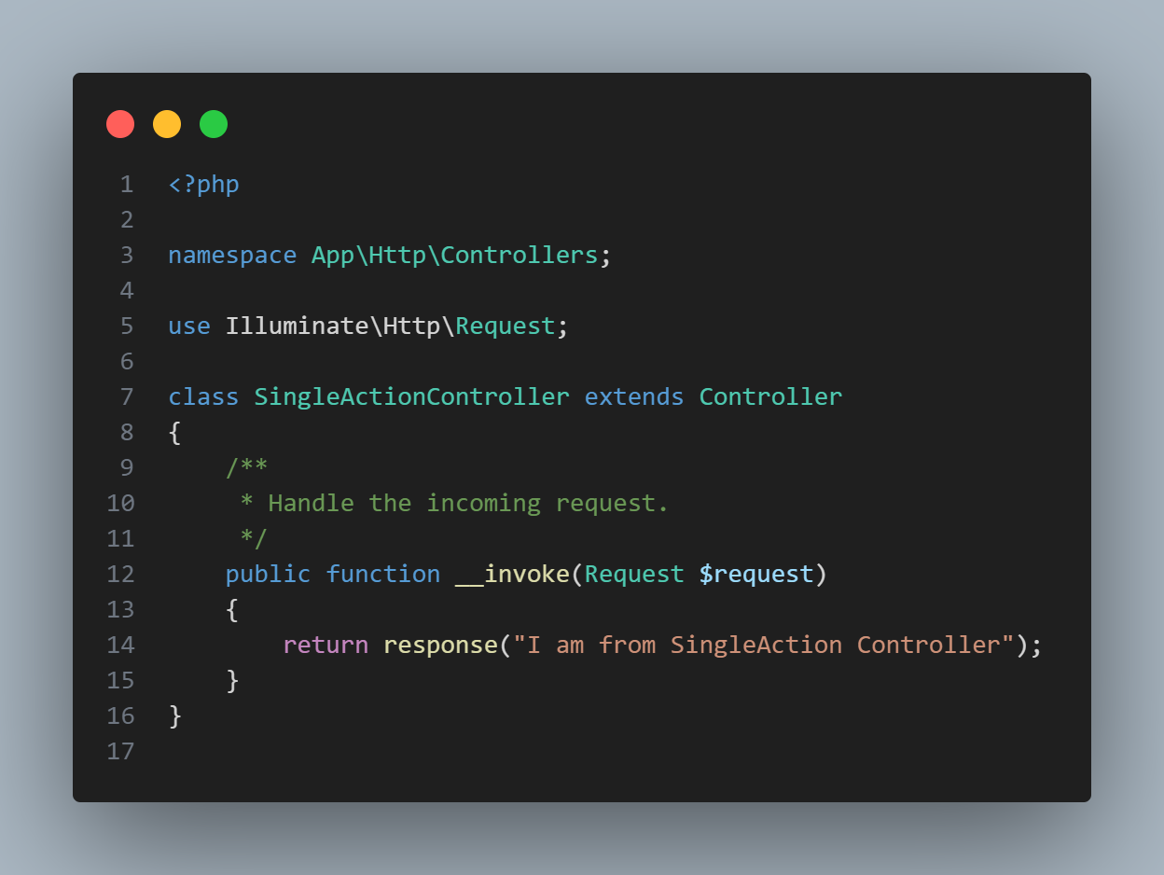

৩.Route বানাব।

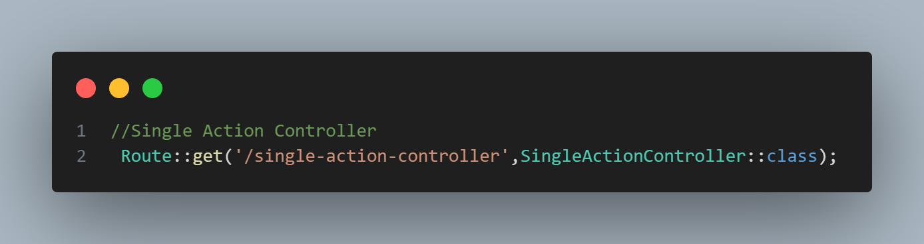

৪.আউটপুট

